

PROJECT REPORT
JAVA PROGRAMMING FUNDAMENTALS
(EBDS22ET2)

2024-2025(EVEN SEMESTER)

DEPARTMENT OF B.Tech DS & AI (E&T)

COURSE : B-TECH CSE-(DS &AI)
YEAR/SEM/SEC : Ist year / IInd sem / AB1

PROJECT TITLE : Lifecycle of threads



BONAFIDE CERTIFICATE

JAVA PROGRAMMING FUNDAMENTALS

DEPARTMENT OF B.Tech DS & AI (E&T)

Certified that this project report “ Lifecycle of threads ” is confirmed work of V.BALAMURUGAN AB1-18,ABISHEK SUNIL SARASWATHY AB1-15,AJESH RK AB1-22 I-year B-Tech CSE- (DS&AI) in JAVA PROGRAMMING FUNDAMENTALS (EBDS22ET2) who carried out the project work under the supervision

Signature of Lab-in-Charge Signature of Head of Dept

Submitted for the Practical Examination held on

Internal Examiner External Examiner

ABSTRACT

- In Java, multithreading allows multiple threads to execute concurrently.

- A thread passes through various stages during its execution known as the thread life cycle.

- Understanding these stages helps developers manage thread behavior and optimize performance.

- This presentation explores each life cycle phase along with practical implementation.

📘 INTRODUCTION TO JAVA:

Java is a high-level, object-oriented programming language developed by Sun Microsystems (now owned by Oracle Corporation). It was designed with the principle of "Write Once, Run Anywhere" (WORA), which means Java programs can run on any device equipped with the Java Virtual Machine (JVM), regardless of the underlying hardware or operating system.
Java is widely used for building a range of applications — from web and desktop software to mobile apps and embedded systems. Its strong memory management, multithreading support, platform independence, and a vast collection of libraries make it a preferred choice for developers.
In this project, Java is used to create a console-based chatbot, demonstrating key features of the language such as:
- Input/output handling using the Scanner class
- Conditional and control statements for decision-making
- Loops for continuous user interaction
- String manipulation and array operations
- Use of standard libraries like java.util, java.time, and java.lang
This project illustrates how Java can be employed to build interactive and user-friendly command-line applications, reinforcing fundamental programming concepts in a practical and engaging manner.

PROJECT TITLE

AIM:

- To understand and demonstrate the different states in the Java thread life cycle.
- To implement Java code that shows transitions between thread states.

ALGORITHMS:

Create a class extending Thread or implementing Runnable.

Override the run() method.

Create a thread instance using the class.

Use start() to move thread from New to Runnable.

Demonstrate sleep (Timed Waiting), join (Waiting), etc.

Let the thread complete execution to reach Terminated state.

SOURCE CODE:

class MyThread extends Thread {
public void run() {
System.out.println("Thread is running...");
try {
Thread.sleep(1000); // Timed Waiting
} catch (InterruptedException e) {
System.out.println("Thread interrupted.");

}
System.out.println("Thread finished.");
}

public static void main(String[] args) {
MyThread t1 = new MyThread();
System.out.println("Thread state after creation: " + t1.getState()); // NEW
t1.start();
System.out.println("Thread state after start(): " + t1.getState()); // RUNNABLE

try {
t1.join(); // Main thread waits
} catch (InterruptedException e) {
e.printStackTrace();
}

System.out.println("Thread state after completion: " + t1.getState()); // TERMINATED
}
}

OUTPUT:

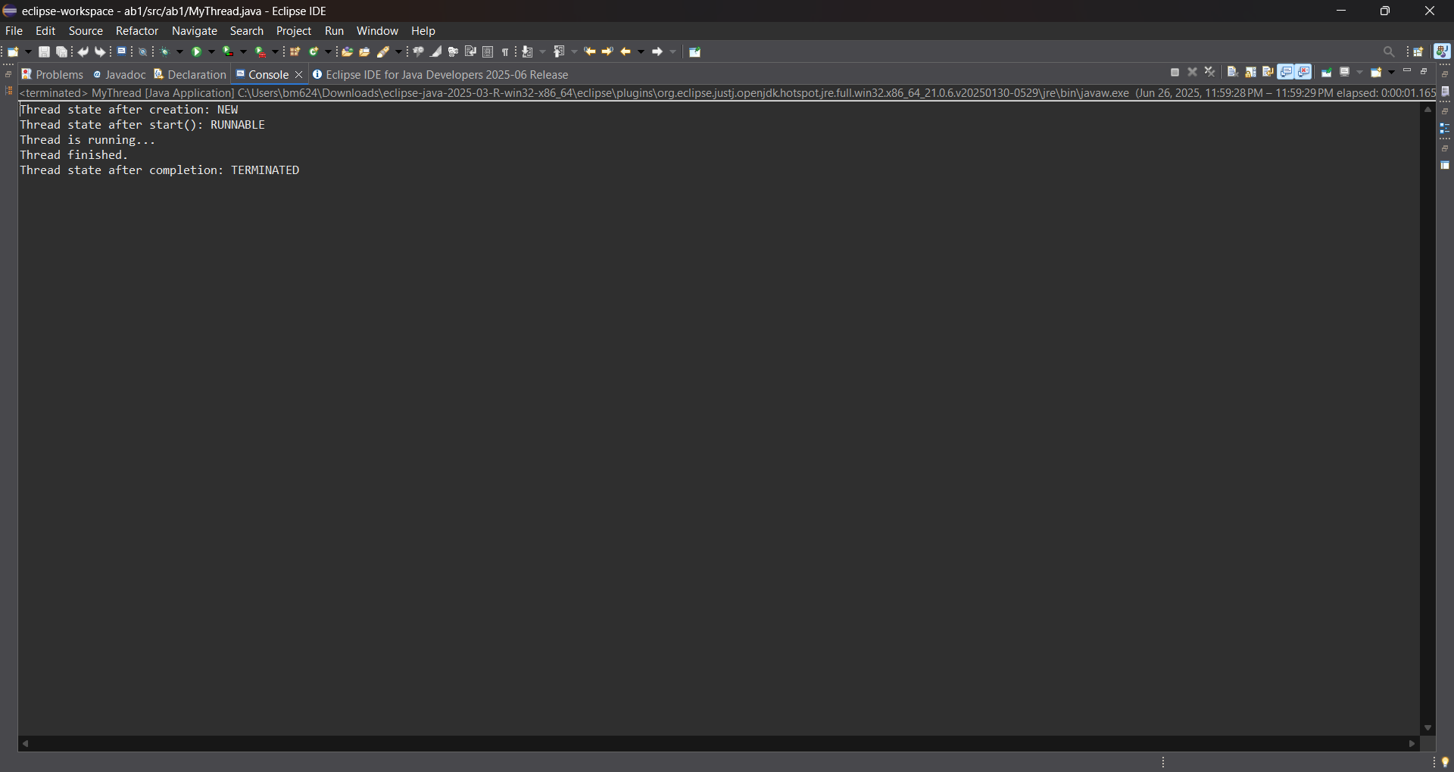

RESULT:

- The code successfully demonstrates thread life cycle states:
  - NEW before start()
  - RUNNABLE during execution
  - TIMED_WAITING during sleep()
  - TERMINATED after run() completes
- It helps visualize thread behavior for better multithreaded programming.

Git huh link : https://github.com/balamurugangethub/life-cycle-of-thread.git

